**User:**

I am a Mechanical Designer, proficient in SolidWorks drafting, and a recent graduate of the University of New South Wales. I would like you to act as both a knowledgeable designer who can provide me with design expertise and a professional engineering designer who can act as a technical advisor to me when I have complex questions.

I like the minimalist and sleek design style of the energy harvesting device. It should look clean and modern without unnecessary details.

The equipment must comply with Australian Standards for Electrical Equipment. The design should be compact to fit into the limited urban space where the installation is specified. Considering the budget of A$50,000, we should prioritise durable materials, balancing cost and longevity.

For this project, I favoured a bio-inspired design approach, using principles found in nature to optimise energy harvesting.

Based on the above background, I will be designing an energy harvesting device.

The energy harvesting device shall require three key modules:

1. The energy accumulation module functions to derive energy from an external source outside the energy harvesting device.

2. The energy storage module functions to store the accumulated energy inside the energy

harvesting device.

3. The energy utilization module utilizes the harvested energy to power other small devices such as sensors, heating/cooling devices, actuators, and low-power devices.

Please give me as many and reasonable and complete designs as possible.

**GPT:**

Designing an energy harvesting device with the considerations and constraints you've mentioned is indeed a fascinating and challenging task. Given your background in mechanical design and proficiency in SolidWorks, along with the design and functionality requirements, here are some conceptual designs and approaches that could be explored for your project:

**1. Design Philosophy: Minimalist and Bio-Inspired**

* **Structure**: A sleek, aerodynamic shape, taking cues from natural elements like leaves or wings for optimal airflow and energy capture.
* **Materials**: Use of durable, lightweight composites or recycled materials to balance cost and longevity, keeping in mind the A$50,000 budget.
* **Color and Texture**: Neutral tones, perhaps with a matte finish to give it a modern and unobtrusive look.

**2. Energy Accumulation Module**

* **Solar Panels**: Thin, high-efficiency photovoltaic cells, possibly flexible to conform to curved surfaces inspired by natural shapes.
* **Wind Turbines**: Small, vertical-axis turbines that are efficient in urban environments and have a design inspired by natural forms like bird wings or tree shapes.
* **Piezoelectric Materials**: Integrated into parts of the device that might experience mechanical stress or vibrations, capturing energy from these movements.

**3. Energy Storage Module**

* **Batteries**: Compact, high-density battery cells for energy storage. Consider the use of emerging technologies like solid-state batteries for greater efficiency and safety.
* **Supercapacitors**: For rapid energy discharge scenarios, which could be useful in powering devices that require quick bursts of energy.

**4. Energy Utilization Module**

* **Modular Connectors**: Design the device with standardized connectors for easy integration with various small devices (sensors, actuators).
* **Smart Management System**: Incorporate a smart system that optimally distributes stored energy based on the demand and priority of the connected devices.

**5. Compliance and Practicality**

* **Australian Standards**: Ensure the design adheres to Australian standards for electrical equipment, particularly in aspects of safety, efficiency, and environmental impact.
* **Compactness**: Aim for a modular design that can be easily fitted in limited urban spaces, possibly with components that can be stacked or interlocked.

**6. Prototyping and Testing**

* Since you are proficient in SolidWorks, start by creating detailed 3D models of the device.
* Use simulation tools within SolidWorks to test the stress, airflow, and energy efficiency of the design.
* Consider creating a small-scale prototype to test in real-world conditions.

**7. Continuous Iteration**

* Keep refining the design based on testing results and feedback.
* Stay updated with new materials and technologies that could enhance the efficiency and cost-effectiveness of the device.

Remember, the key is to balance aesthetics, functionality, cost, and compliance with standards. It's a process of continuous iteration and improvement. Since you have a clear vision and the technical skillset, your journey in designing this energy harvesting device should be a rewarding one. Keep in mind the importance of detailed documentation and rigorous testing to ensure the final product meets all the necessary criteria and performs optimally in its intended environment.

**User:**

Based on the scenario you gave me above, please generate a visual concept diagram.

**GPT:**

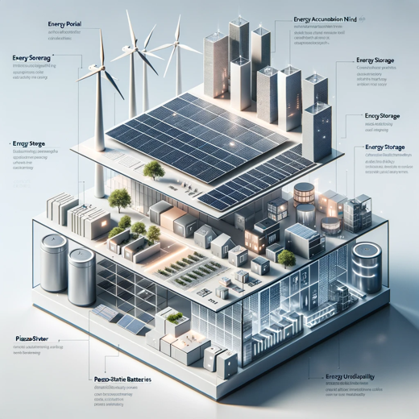

Here is the visual concept diagram for the energy harvesting device incorporating the three key modules as described.